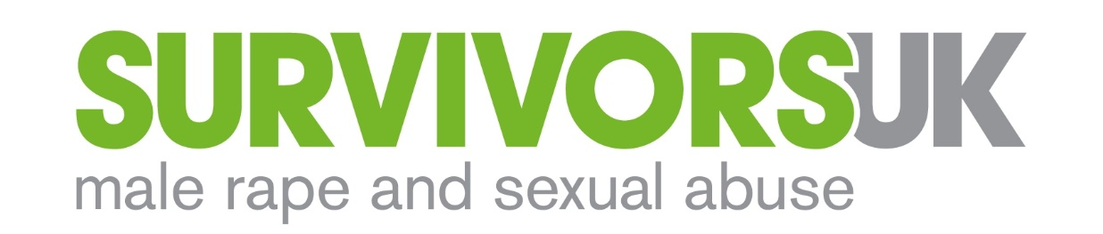

Job Title | Groupwork+ Facilitator
Salary | £15 per hour planning, preparation £25 per hour delivery
Hours | Group preparation and delivery. Hours (largely evenings and weekends) to be negotiated by mutual agreement with the organisation (zero-hours contract)  + 2-4 hours per month of team meetings, supervision and line management
Location | Based Shadwell/Wapping, E1 & other London based venues
Contract Type | Two year contract with possible extension or renewal subject to funding
Reports to | Groupwork Co-ordinator
Annual Leave | Equivalent to 28 days per annum + bank holidays (pro rata)

CONTEXT

An estimated 12,000 men are raped every year and 76,000 sexually abused or assaulted. Yet just 4% of men will tell someone. Of those who do, it takes on average 26 years to do so.
SurvivorsUK provides specialist support to men and boys, trans and non-binary people who have been raped, sexually assaulted or abused. Our aim is to help any man, boy or gender non-confirming person to have the confidence to tell someone what’s happened to them and to know that it’s OK to seek help. When they do, we want to ensure they have access to the right support so they can deal with the impact of their experiences of criminal harm.
We provide emotional support, information and signposting to survivors and anyone worried about someone they know, through a national website and webchat service (open till 9pm most evenings). Last year, 2,600 people contacted us via our webchat services and social media.
In London, we are the only organisation providing specialist services for men and boys, including individual counselling and therapeutic groupwork, available till 9pm six days a week. Across London, we provide the capital’s only Independent Sexual Advisor (ISVA) Service that helps men and boys through the criminal justice system.

ABOUT THE ROLE
Groupwork+ is an exciting and challenging project at SurvivorsUK. It builds on the success of our Groupwork pilot to meet the needs of more men, across a wider area of London, reaching more diverse communities. Groupwork+ helps men with complex and high support needs, including men for whom generic services don’t work.
You will need to be a highly skilled groupwork facilitator with experience of dealing with extremely vulnerable clients, willing to work flexibly and on your own initiative. Importantly, you will be a compassionate person able to blend therapeutic work with practical support and care.

This post is subject to an enhanced DBS Clearance

PURPOSE
- Facilitate groupwork interventions for male, trans and nonbinary victims/survivors of sexual abuse, assault and rape, including in the evenings and at weekends
- Manage safeguarding issues in conjunction with the Groupwork Coordinator and the organisation’s safeguarding lead
- Record all client work and risks on Salesforce as per organisation procedure
- Develop plans for group sessions and continue to develop the group model
- Ensure that monitoring and evaluation is considered at all times and outcomes are recorded

KEY OUTCOMES
- Service users who are highly vulnerable, isolated and/or distressed will have access to a service that meets their needs, with improvements in their overall health and wellbeing
- Service users will report feeling better able to cope with their experiences of trauma
- Service users will report feeling less isolated and confident to open up and talk about their experiences in a community of men
- Professionals working with vulnerable men and boys will report increased confidence and ability to respond to sexual violence trauma

RESPONSIBILITIES

- Services Delivery

- You will assist in the planning, set up and facilitation of some of the following groups:
- The Core twelve session closed group programme. These groups are held on a Friday and Monday evening and a Saturday daytime
- An open young people’s group
- An open monthly group for survivors who are trans or nonbinary
- A new programme of social activities for survivors
- A quarterly psycho-educational workshop on the impact of trauma and sexual violence
- A service user panel
- An annual wellbeing day
- Groups for families, friends and loved ones
- Other groups which may be developed as part of an evolving groupwork programme
- Attend supervision, CPD/training days and line management as required

- Liaison and Promotion
Assist the Groupwork Co-ordinator to:
- Engage with external agencies in the charity and public sectors to promote our services to them and their client communities. Specifically, but not exclusively, within homelessness, mental health, drug/alcohol services, HIV charities and relevant statutory agencies
- Maintain good working relationships with other support services associated with the client
- Working with SurvivorsUK Digital Marketing and Website Officer, provide content for promotion of the service via website and social media, including leaflets and press activity
- Establish relationships with other organisations to raise the profile of SurvivorsUK, the groupwork service and encourage referrals
- Hold awareness sessions within community organisations for potential clients

- Monitoring, evaluation and dissemination

Assist the Groupwork Co-ordinator to:
- Collect and accurately record data, including presenting issues, client notes, socio-economic demographics, using SurvivorsUK Salesforce database
- Monitor individual client’s progress through the CORE outcomes monitoring framework
- Prepare information and data to help the Operations Manager in the preparation of monitoring reports to funders and to the Board of Trustees
- Where appropriate, and within safeguarding and data protection policies, collate qualitative client stories for reporting back to funders, evidencing need and service user opinion/feedback
- Ensure all clients are aware of and have access to the organisation’s relevant policies, procedures and other documents

- General Duties

- Provide input and comment on the development of SurvivorsUK policies and procedures and ensure you follow established procedures
- As a member of a small team, contribute to the development of new initiatives and services in response to client need
- Answering the telephone, and other general office duties where needed

The post-holder will be required to carry out additional duties from time to time. Such duties will be commensurate with the role.

SurvivorsUK is an equal opportunities employer

PERSON SPECIFICATION

Experience and qualifications

- A BACP or UKCP or equivalent accredited counsellor, psychotherapist or groupwork facilitator
- At least 2-years’ experience of working with highly vulnerable clients in a counselling and/or groupwork service
- Proven track record in helping clients who are experiencing high levels of distress and/or chaotic lifestyles, to improve their health and wellbeing
- Efficient and accurate use of outcomes monitoring frameworks, such as CORE or equivalent

Skills, knowledge and competences

- Strong understanding of the experiences, needs and impact of rape, sexual abuse or assault on men, whether as a child or adult
- Self-motivated and a self-starter: high level of confidence to develop and deliver a new service
- A mature, calm and empathic manner: able to engage with clients who have challenging needs and deal with highly emotional and stressful situations
- Strong communication skills: able to build trusting relationships and rapport with clients and interact and engage effectively with external agencies
- Adherence to confidentiality and boundary policies and practices
- High degree of flexibility in approach to working with clients and the wider team
- Positive attitude and willing to contribute to developments, improvements and changes more broadly within SurvivorsUK
- Competent administrator and highly organised: committed to maintaining accurate client records and reporting on performance
- Demonstrable commitment to equal opportunities, with a non-judgemental approach to helping men
- A commitment to pursuing professional excellence, personal development and learning

