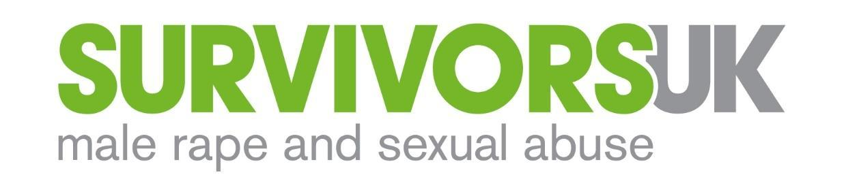

Role specification

Job Title | Emotional Support Worker
Salary | £28,560 per annum, pro rata
Hours | - 12 hours a week (Mondays, 12-4pm; Thursdays, 4-8pm; Fridays, 12-4pm)  - + around 4 hours per month of team meetings, line management and supervision  - + opportunity for overtime.
Location | Work from home during the COVID pandemic. You must have a private, confidential home working environment to be considered for this role.  When safe, Shadwell/Wapping (E1) on weekdays, except by prior agreement with your line manager. Weekend shifts are always worked from home.
Contract | Fixed term to 31st March 2022, with extension subject to funding
Reports to | Webchat Coordinator
Holiday pay | Equivalent to 28 days per annum + bank holidays (pro rata)
Other benefits | Free, confidential Employee Assistance Programme including a 24/7 helpline, counselling, CBT and wellbeing resources online.
Deadline | 10pm on Wednesday 21st October, 2020
Other key dates (all taking place online) | 20-minute assessment: Monday 26th October, between 9am and 1pm  Interviews: Thursday 5th November  Start date: Thursday 19th November, ideally  Training (mandatory): Saturday 5th December

This post is subject to an enhanced DBS Clearance.

We are a diverse helpline team and strongly encourage applications from people from structurally oppressed communities and people who share some of the identities of our service users.

SurvivorsUK is committed to continually developing our practice as an equal opportunities employer.

PURPOSE

- Deliver high quality emotional support, information, signposting and referrals to male and non-binary survivors of sexual abuse, assault and rape - and to their friends, family, partners and professionals - via webchat, email, SMS, Whatsapp, telephone and other channels.
- As a member of a small team, contribute creatively to the development of emotional support services (including policies, procedures, marketing and self-help materials), and of the organisation in response to client need.

KEY OUTCOMES

- All callers receive support that is appropriate to their needs and of the highest possible quality.
- All enquiries are responded to efficiently and effectively, and offered signposting and referrals when necessary.
- Safety issues and concerns and risk are managed according to SurvivorsUK policies, and relevant managers and staff members are informed where appropriate.

CONTEXT

An estimated 12,000 men are raped every year and 76,000 sexually abused or assaulted. Yet just 4% of men will tell someone. Of those who do, it takes on average 26 years to do so.
Noone knows how many non-binary people are raped, sexually abused or assaulted, less still how many will tell someone.
SurvivorsUK provides specialist support to men, boys and non-binary people who have been raped, sexually assaulted or abused, and to anyone who feels less able to access women’s sexual abuse services because of gender.
Our aim is to help people to have the confidence to tell someone what’s happened to them and to know that it’s OK to seek help. When they do, we want to ensure they have access to the right support so they can deal with the impact of their experiences of harm.
We provide emotional support, information and signposting through a website and national, text-based helpline services, 12pm to 8pm, 7 days per week.
In London, SurvivorsUK is the only organisation providing specialist services for men and boys, including nationwide individual counselling and therapeutic groupwork, available till 9pm six days a week, and an Independent Sexual Advisor (ISVA) Service that helps men, boys and non-binary people through the criminal justice system.

RESPONSIBILITIES

- Service Delivery
- Provide emotional support, information, signposting and referrals via webchat, email, SMS, Whatsapp, telephone and other methods.
- Assess risk and safety of callers, participate in safeguarding decision-making in consultation with managers, and implement safeguarding procedures where necessary.
- Record data for monitoring and complete relevant statistical forms, according to SurvivorsUK GDPR policy, and participate in overall service monitoring and evaluation.
- Adhere to the service’s remit, all relevant SurvivorsUK policies and procedures, and the BACP Code of Ethics.
- Attend mandatory monthly group supervision and participate in ongoing training.
- Ensure all clients are aware of and have access to the organisation’s complaints policy and terms of use.
- Collate qualitative client stories for reporting back to funders, evidencing need and service user opinion (where appropriate and within safeguarding and GDPR policies).
- Support emotional support volunteers in their role and provide debrief at the end of shift.
- Support initial training and provide ongoing training for emotional support volunteers.
- Feed back any concerns raised by volunteers and take note of time keeping and attendance of volunteers.

- Liaison and Promotion
- Engage with external agencies in the charity and public sectors to promote our work, policies and aims, including to homelessness, mental health, drug/alcohol services, HIV charities, sexual and domestic violence and relevant statutory agencies.
- Working with the Digital Communications Officer, provide content for promotion of the service via website and social media.
- Respond to media enquiries
- Assist with research and development of marketing and self-help materials.

- General Duties
- Ensure that the standards of service delivered comply with the organisation’s mission statement, policies, business plan and other related guiding principles at all times.
- Carry out additional duties from time to time, commensurate with the role.

PERSON SPECIFICATION

Experience and qualifications (essential)
- At least 1 year’s experience of working in a helpline, counselling or related support service.
- At least 1 year’s experience of working with survivors of sexual abuse, assault and rape, and/or male or non-binary people with complex needs.
- Experience of working in an organisational setting providing information, guidance and signposting to relevant services.

Experience and qualifications (desirable)
- Experience of providing written emotional support (e.g. by webchat).
- A BACP or UKCP or equivalent accredited counsellor, psychotherapist or CBT practitioner.

Skills, knowledge and competences (essential)
- Strong understanding of the experiences, needs and impact of rape, sexual abuse or assault on men, boys and non-binary people aged 13+.
- Calm, compassionate manner: able to empathise and engage with clients who have challenging needs and deal with highly emotional and stressful situations.
- Strong communication skills: able to build trusting relationships and rapport with clients of wide-ranging identities and backgrounds, and engage effectively with external agencies.
- Demonstrable commitment to equal opportunities, with a non-judgmental approach to helping men (transgender and cisgender) and non-binary people.
- Able and willing to adhere to boundaries and confidentiality policies and practices.
- Confident user of computers, able to learn quickly how to use web-based chat systems.
- Organised and a competent administrator, committed to maintaining accurate client records and reporting.
- Flexible approach to working with clients and the wider team.
- Able to work independently and to ask for help when needed.
- Able to reflect and be self-aware with regard to self-care.
- Committed to pursuing professional excellence, personal development and learning.
- Positive attitude and willing to contribute to developments, improvements and changes more broadly within SurvivorsUK.

Skills, knowledge and competences (desirable)
- Knowledge of legal frameworks regarding sexual violence.

