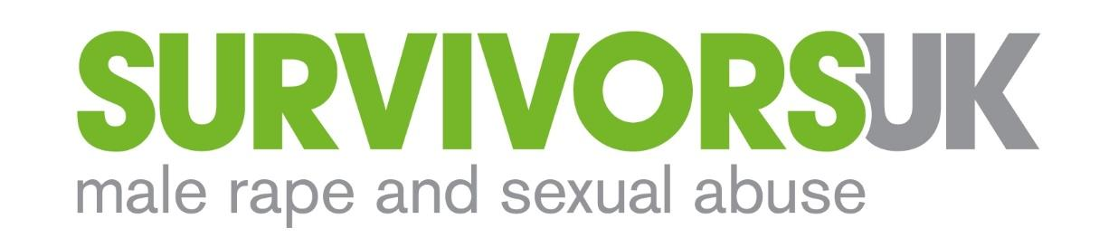

Job Title | Support Counsellor / CBT Practitioner
Salary | £32,000
Hours | 35/week
Location | Work from home during the COVID-19 pandemic. You must have a private, confidential home working environment to be considered for this role.  When safe, Shadwell/Wapping (E1), except by prior agreement with your line manager.
Contract Type | Fixed term for 12 months
Reports to | Counselling lead
Annual Leave | 28 days per annum + Bank Holiday (pro rata)

CONTEXT
An estimated 12,000 men are raped every year and 76,000 sexually abused or assaulted. Yet just 4% of men will tell someone. Of those who do, it takes on average 26 years to do so.
SurvivorsUK provides specialist support to (cis and trans*) men, boys and non-binary people who have been raped, sexually assaulted or abused. Our aim is to help any man, boy, or non-binary person, to have the confidence to tell someone what’s happened to them, and to know that it’s OK to seek help. When they do, we want to ensure they have access to the right support so they can deal with the impact of their experiences.
We provide emotional support, information and signposting to survivors and anyone worried about someone they know, through a national website and webchat service (open till 8pm most evenings). Last year, 2,600 people contacted us via our webchat services and social media.
In London, we are the only organisation providing specialist services for men and boys, including individual counselling and therapeutic groupwork, available till 9pm six days a week. Across London, we provide the capital’s only Independent Sexual Advisor (ISVA) Service that helps men and boys through the criminal justice system.

ABOUT THE ROLE
This is an exciting and challenging new role at SurvivorsUK, that combines brief counselling and practical support, specifically to the (circa) 200 people on our waiting list for ongoing counselling. It is designed to help people cope during the 9-12 month wait for regular counselling support. The people served include those with clinical mental health diagnoses, drug and alcohol dependencies, at risk of suicide, homelessness or involved in the sex industry.
You will need to be a highly skilled counsellor/practitioner with experience of dealing with highly vulnerable clients, willing to work flexibly and on your own initiative. Importantly, you will be a compassionate person able to blend therapeutic work with practical support and care.

This post is subject to an enhanced DBS Clearance

PURPOSE
- Provide counselling, therapy and practical support interventions to men, boys and non-binary people who have been raped, sexually abused or assaulted with high levels of need and who are most vulnerable.
- Collaborate with clients on ongoing assessment of their needs
- Support the monitoring and reporting to funders on the development and delivery of the service.

KEY OUTCOMES
- Survivors who are highly vulnerable and distressed will have access to a service that meets their needs, with improvements in their overall health and wellbeing.
- A reduction in harmful behaviours, such as less suicidal ideation, reduced drug & alcohol use, reduced incidences of self-harm.
- Survivors who are leading chaotic lifestyles report feeling more stable, better able to cope and better supported.

RESPONSIBILITIES

- Service Delivery
- Provide input to develop and improve SurvivorsUK support for people waiting for regular counselling
- Deliver brief interventions by phone, video calling and face-to-face
- Maintain accurate and timely client case notes, ensuring adherence to confidentiality, safeguarding and data protection procedures.
- With clients, develop action plans to help them address emotional and practical needs and ensure clients can engage with a flexible service.
- Provide regular and timely communications with clients so that they are encouraged to remain with the service.
- Provide advocacy to help clients overcome practical issues (i.e. benefits, debts, housing), including linking to external agencies.
- Attend clinical supervision.

- Liaison and Promotion
- Maintain good working relationships with other support services associated with the client.

- Monitoring, evaluation and dissemination
- Collect and accurately record one-to-one contact data, including presenting issues, client notes, socio-economic demographics, using SurvivorsUK Salesforce database.
- Monitor individual client’s progress through the CORE outcomes monitoring framework.
- Where appropriate, and within safeguarding and data protection policies, collate qualitative client stories for reporting back to funders, evidencing need and service user opinion.
- Ensure all clients are aware of and have access to the organisation’s complaints policy.

- General Duties
- Be responsible for administrative functions associated with the role, including accurate record keeping and filing.
- Provide input and comment on the development of SurvivorsUK policies and procedures and ensure you follow established procedures.
- As a member of a small team, contribute to the development of new initiatives and services in response to client need.

The post-holder will be required to carry out additional duties from time to time. Such duties will be commensurate with the role.

SurvivorsUK is an equal opportunities employer.

PERSON SPECIFICATION

Experience and qualifications
- A BACP, UKCP or BABCP accredited counsellor, psychotherapist or CBT practitioner.
- At least 2-years’ experience of working with highly vulnerable clients in a counselling and/or support service.
- Demonstrable caseload management, with experience of undertaking initial counselling assessments.
- Proven track record in helping clients who are experiencing high levels of distress and/or chaotic lifestyles, to improve their health and wellbeing.
- Efficient and accurate use of outcomes monitoring frameworks, such as CORE or equivalent.

Skills, knowledge and competences

- Strong understanding of the experiences, needs and impact of rape, sexual abuse or assault on (cis and trans*) men and boys, and on non-binary people
- Self-motivated and a self-starter: high level of confidence to develop and deliver a new service.
- A mature, calm and empathic manner: able to engage with clients who have challenging needs and deal with highly emotional and stressful situations.
- Strong communication skills: able to build trusting relationships and rapport with clients and interact and engage effectively with external agencies.
- Adherence to confidentiality and boundary policies and practices.
- High degree of flexibility in approach to working with clients and the wider team.
- Positive attitude and willing to contribute to developments, improvements and changes more broadly within SurvivorsUK.
- Competent administrator and highly organised: committed to maintaining accurate client records and reporting on performance.
- Demonstrable commitment to equal opportunities, with a non-judgemental approach to helping men, non-binary and trans people
- A commitment to pursuing professional excellence, personal development and learning.

